Paula Andrea Díaz Vanegas

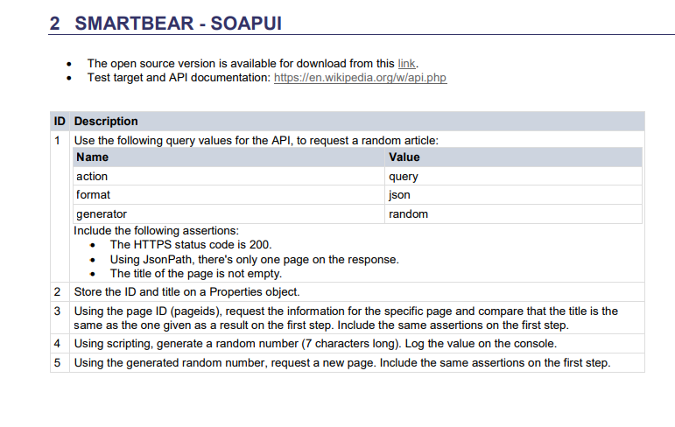

1. First step: Create Request and verify that title is not empty

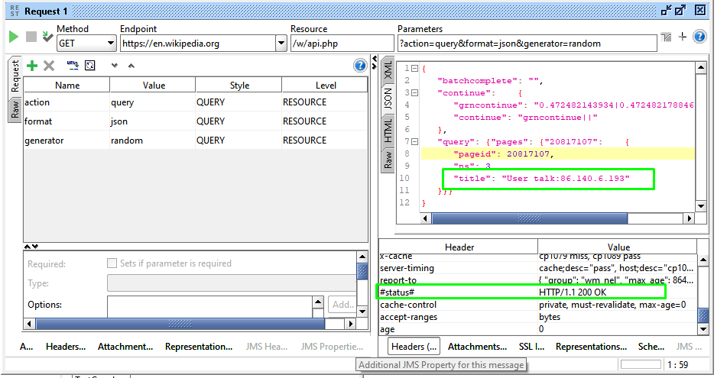

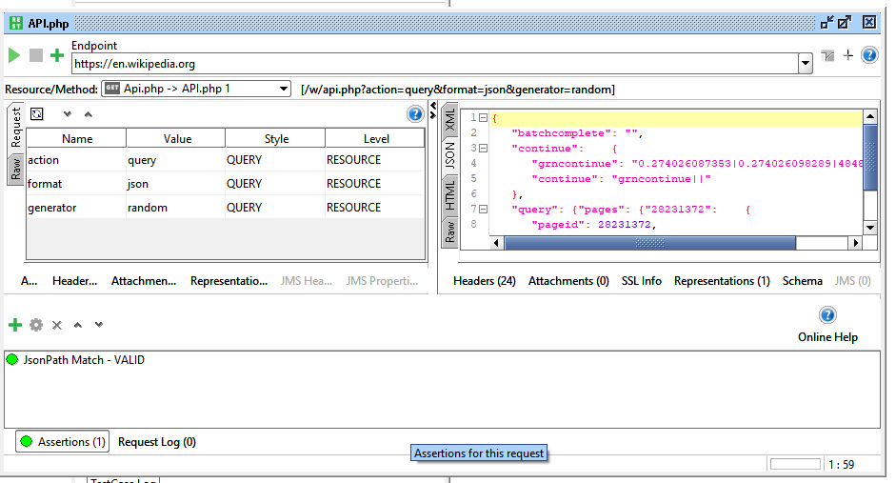

Assertion:

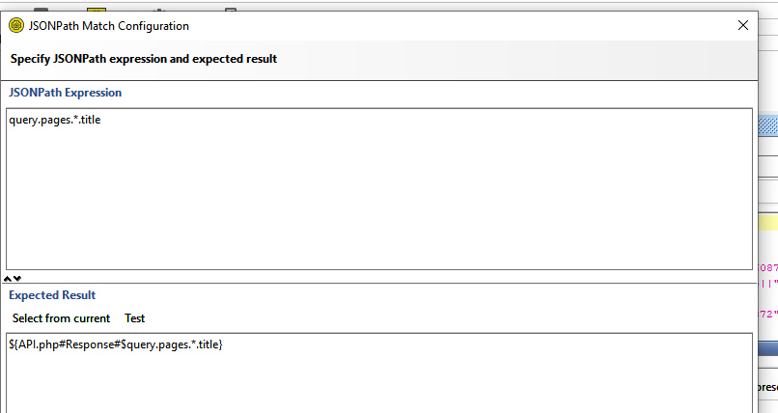

1. Second step: Create properties for title and pageid

First you need to create “Property Transfer”and inside it the two properties are created

PropertyTransferTitle:

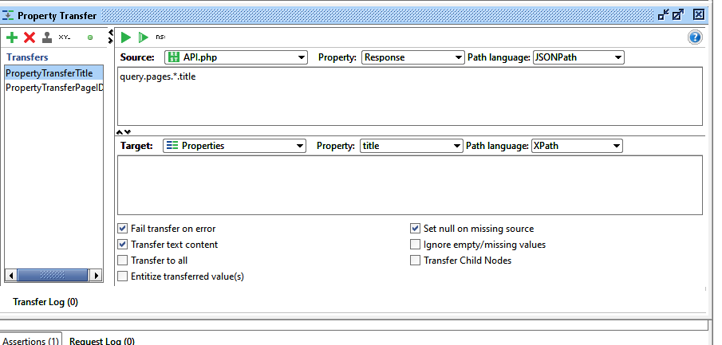

PropertyTransferPageID

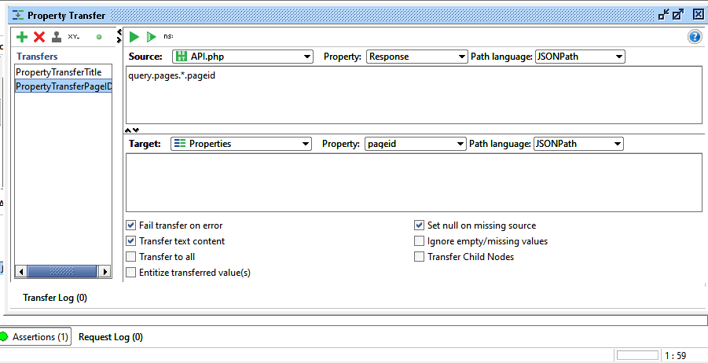

Then, create a properties for title and page id

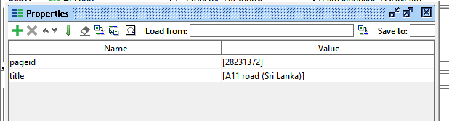

1. Using the page ID (pageids), request the information for the specific page and compare that the title is the same as the one given as a result on the first step. Include the same assertions on the first step.

REQUEST:

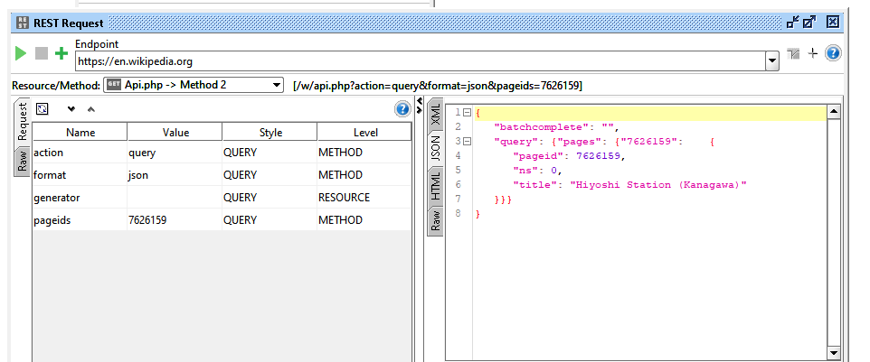

1. Using scripting, generate a random number (7 characters long). Log the value on the console

First, create a property transfer por pageid

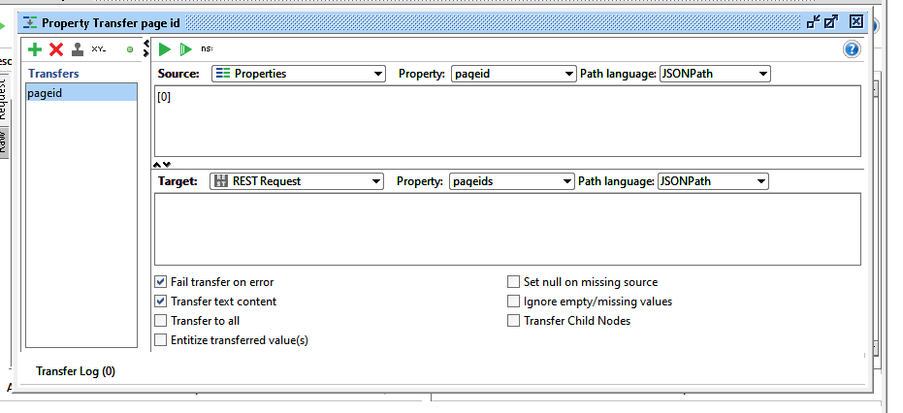

Create a new “Groovy script” for generate a random number:

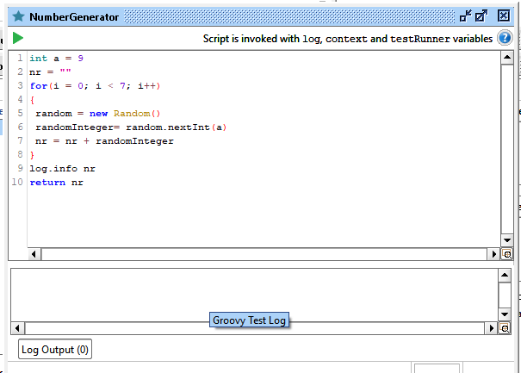

Result on console

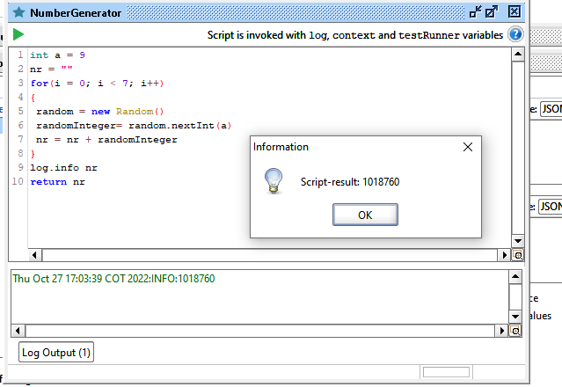

1. Using the generated random number, request a new page. Include the same assertions on the first step.

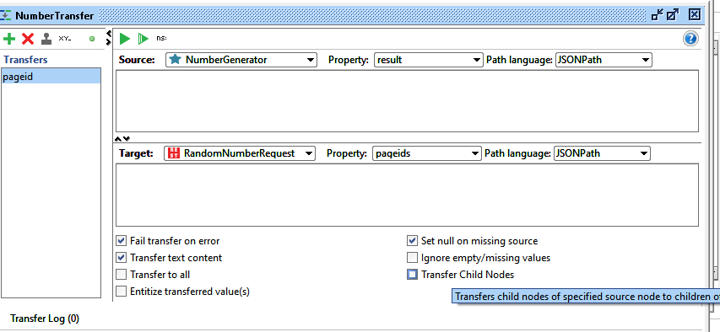

Create a new request

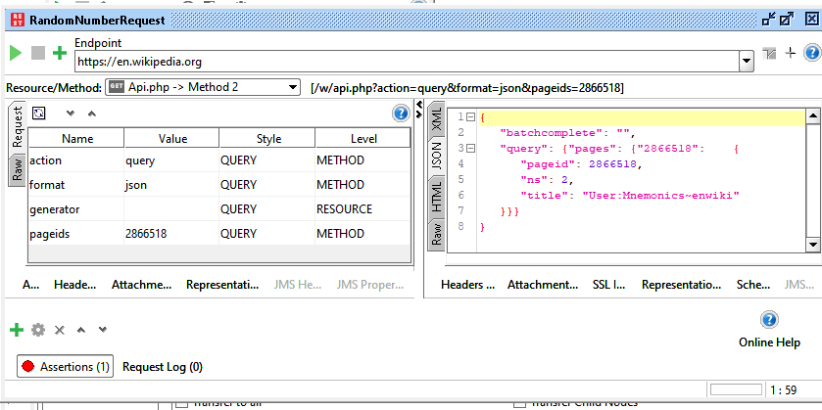

Assertion:

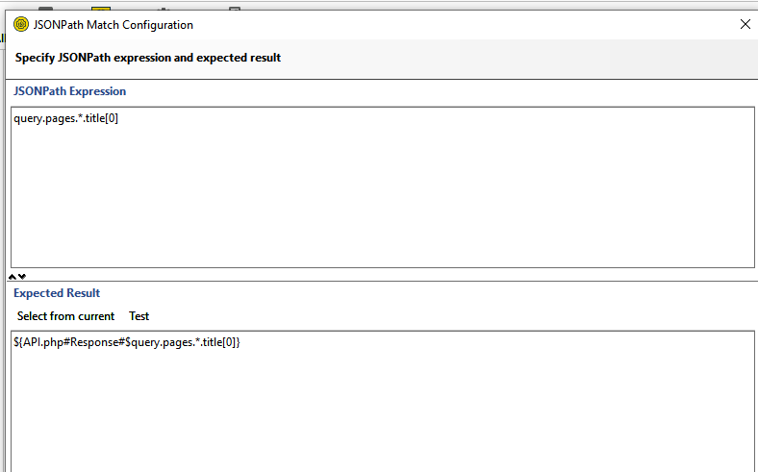

the probability of finding the first pageid at the time of generating another query is low.

Steps 1-4:

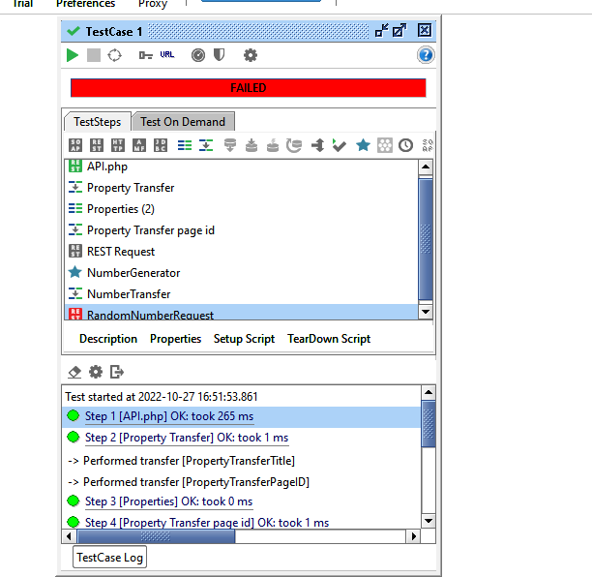

Steps 5-8

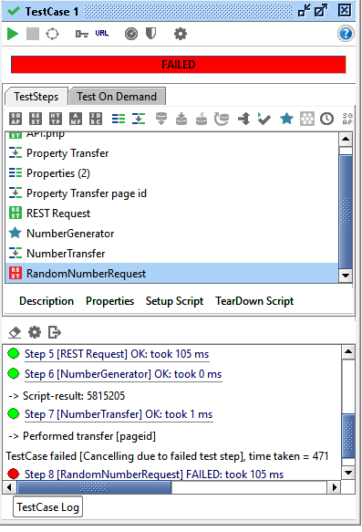

Details step 8

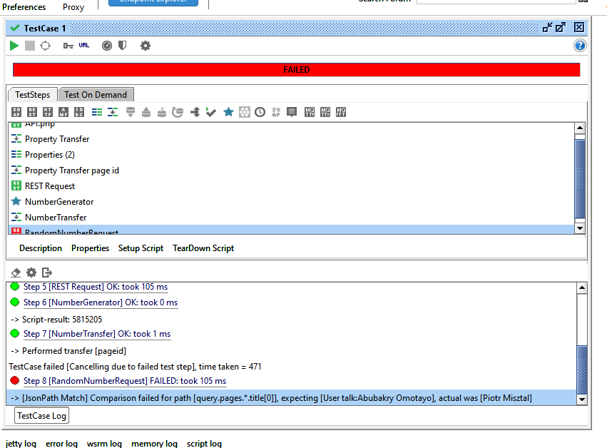

Structure:

